Lab Objective

Configuring SMTP server in the File Server Resource Manager.

**Lab Procedures**

1. In the File Server Resource Manager, Right click the first node in the right pane “File Server Resource Manager” and select “Configure Options.”
2. In the File Server Resource Manager Option window, select “Email Notifications” tab. Add the SMTP server name or IP address

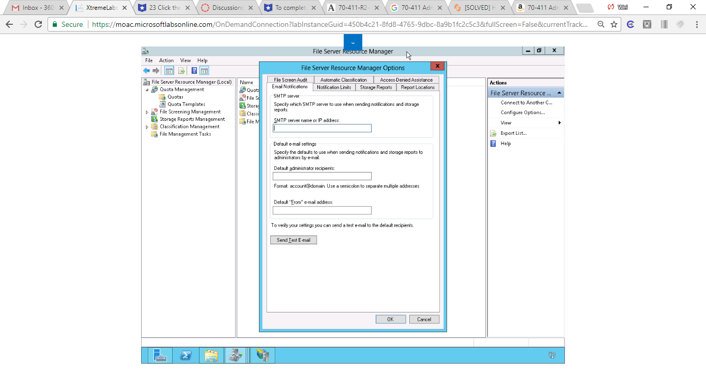

Figure 1 In the File Server Resource Manager Option window, select “Email Notifications” tab

1. In the Default e-mail settings box, type the local email address for the file administrator
2. Add Default “From” e-mail address
3. In the File Server Resource Manager, click Quota Tempaltes
4. Double-click QuotaTempalte1
5. Under Notifcation thresholds, click Warning(85%)
6. Click Edit…
7. Under E-mail Message Tab, check Send e-mail to the following administrators. And type the email.

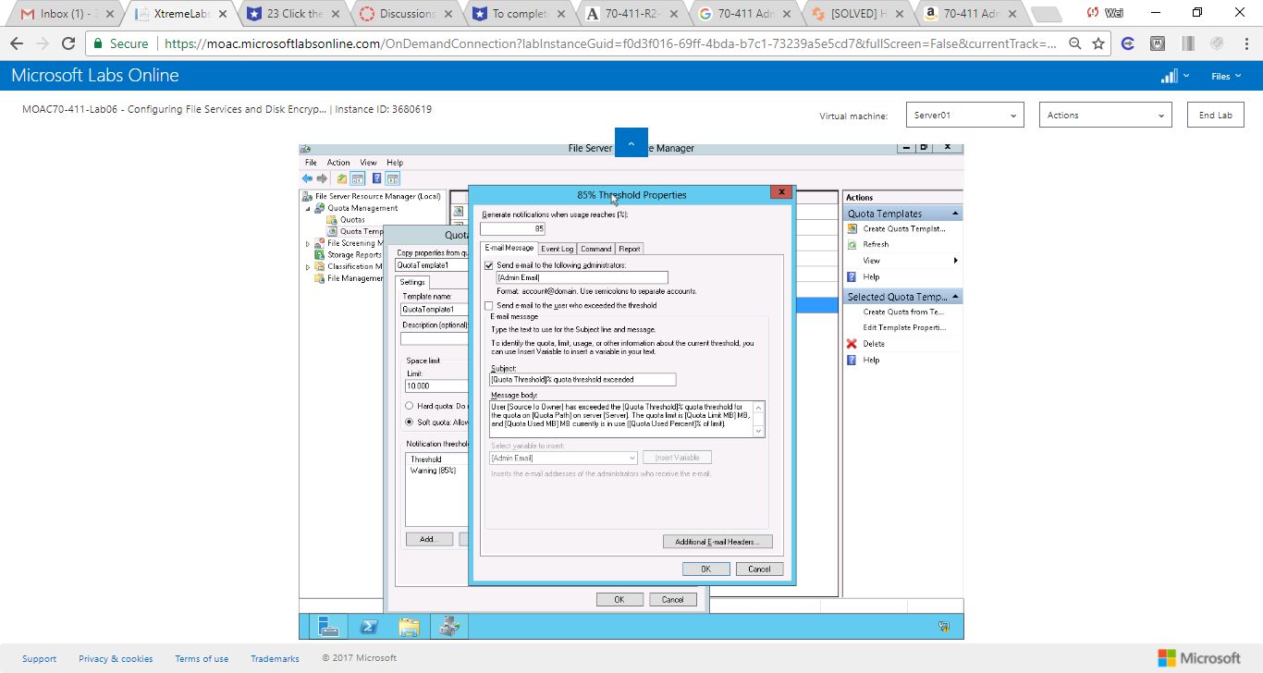

Figure 2 Under E-mail Message Tab, check Send e-mail to the following administrators. And type the email

1. Click Ok to save the properties.

**Lab Summary**

During this exercise, I enabled SMTP for FSRM by the steps provided above. I tried to setup my Gmail initially, but figured out FSRM does not support an account with authorization. There are several ways to set it up correctly. 1. Configure a server in my domain with IIS and make it an open relay. It can then forward the mail with an authenticated account to some other service. 2. Install a program like hmail and use it as the open relay to an authenticated account. 3. Configure an account in my own email system to not require authentication.